Exercises sheet: An introduction into (not) taxing wealth and profits - The Dutch case

Exercise 1: Find the missing profits

Step 1
Student guess for themselves the top 5 countries that lose most corporate tax revenue (in absolute terms) from the Netherlands. Write down the top 5 of each student next to each other.

Top 5 - Person 1:

Top 5 - Person 2:

Top 5 - Person 3:

Step 2
Discuss and write down in your group what the reasons are you choose these countries and what can cause/explain high corporate tax losses to the Netherlands for countries:

Step 3
Go to https://missingprofits.world/ and find out what the actual top 5 is by clicking on countries in the map. Write down the data regarding the Netherlands and all tax havens (absolute profits lost, absolute tax revenue lost, and relative tax revenue lost; in total thus 6 items per country) for each country that you click on.

 | Lost corporate tax revenue to NL |  |  | Lost corporate tax revenue to all tax havens
 | Profits lost ($, Millions) | Tax revenue lost ($, Millions) | Tax revenue lost (% of corp. tax revenue) | Profits lost ($, Millions) | Tax revenue lost ($, Millions) | Tax revenue lost (% of corp. tax revenue)
Country 1
Country 2
Country 3
Country 4
Country 5
Country 6
Country 7
Country 8
If needed add more countries here

Step 4
Compare the results to your guesses of step 1 and discuss the similarities and differences.

Step 5
Discuss which of the reasons you discussed at step 2 seems to have led you in the right direction.

Exercise 2: Power mapping

Step 1: Early 2000s
Place the following actors in the graph:
- The general public
- Politicians
- Multinational corporations
- Civil society organisations
- Academic researchers
- Tax lawyers and advisors
- Tax inspectors
- International organisations (EU, OECD, G20)

Discuss why they should be placed there and how this can help explain policy outcomes.

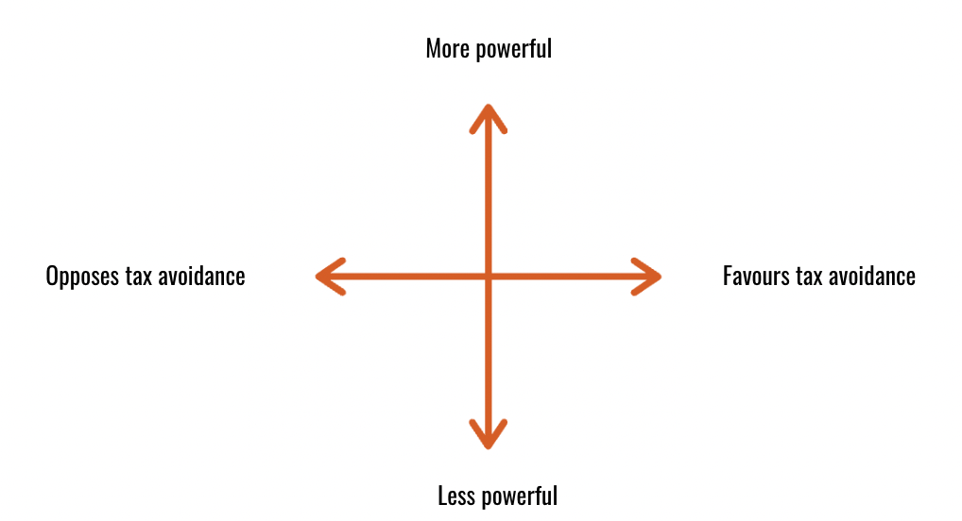

Step 2: Today
Replace the following actors in the graph:
- The general public
- Politicians
- Multinational corporations
- Civil society organisations
- Academic researchers
- Tax lawyers and advisors
- Tax inspectors
- International organisations (EU, OECD, G20)

Discuss why they should be placed there and how this can help explain policy outcomes.

